**Blog Application:**

**Introduction of project :**

**Techstack used in the project:**

**An alternative that can be used to build the project and why Mern stack is used :**

**Why mern stack to build this project?**

**Difficulties or Challenges faced :**

* **Tech Challenges:**
* **General Challenges:**

**Future Improvements of Projects: Ex. Chatbot, likes, dislike, recommendations and how**

**Technical Execution of Front End and Backend with API calls:**

**What is rest api:**

**Implementation of unordered_map:**

**BACKEND:**

1. **Express :**

**INTERVIEW QUESTIONS:** [**https://www.javatpoint.com/expressjs-interview-questions**](https://www.javatpoint.com/expressjs-interview-questions)

**Routing Simple Code:**

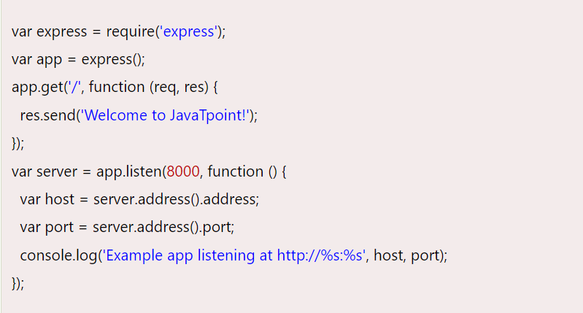

**Features of Express:**

1. **Express**.js can be used to design single-page, multi-page, and hybrid web applications and APIs.
2. It allows to set of middleware to respond to HTTP/RESTful Requests.
3. It defines a routing table to perform different HTTP operations (method and URL).
4. Its robust API makes routing easy.
5. It provides good database support. It supports RDBMS as well as NoSQL databases.

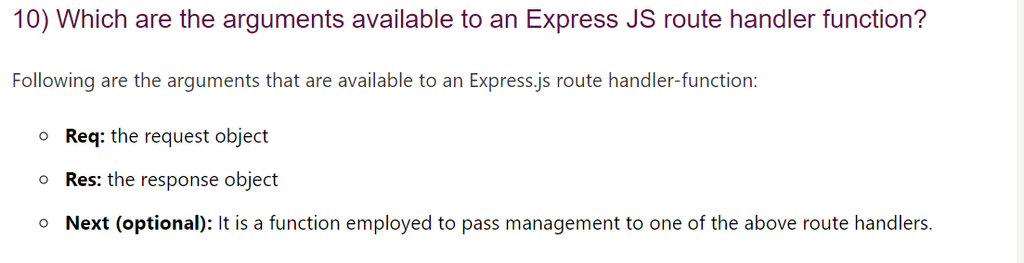

**However we can use simple HTTP module of nodejs to write server side logics but its quite complicated so main reason for choosing Express is its simplicity, minimalism, flexibility, and scalability characteristics**.

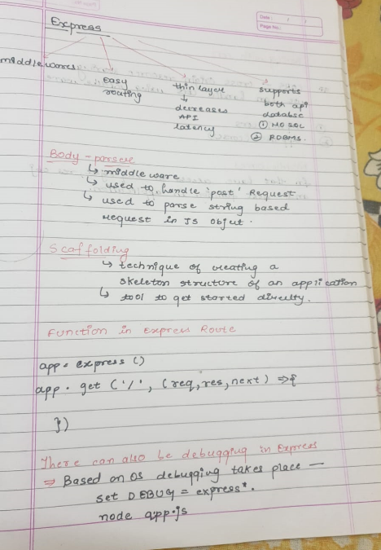

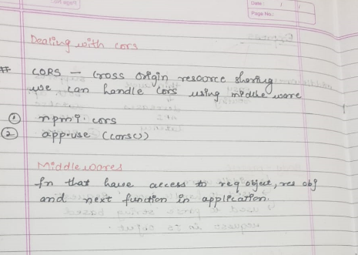

1. **MongoDB:**

**Queries:** [**https://mongoosejs.com/docs/queries.html**](https://mongoosejs.com/docs/queries.html)

**INTERVIEW :** [**https://www.interviewbit.com/mongodb-interview-questions/**](https://www.interviewbit.com/mongodb-interview-questions/)

**Interview Questions: https://www.interviewbit.com/mongodb-interview-questions/**

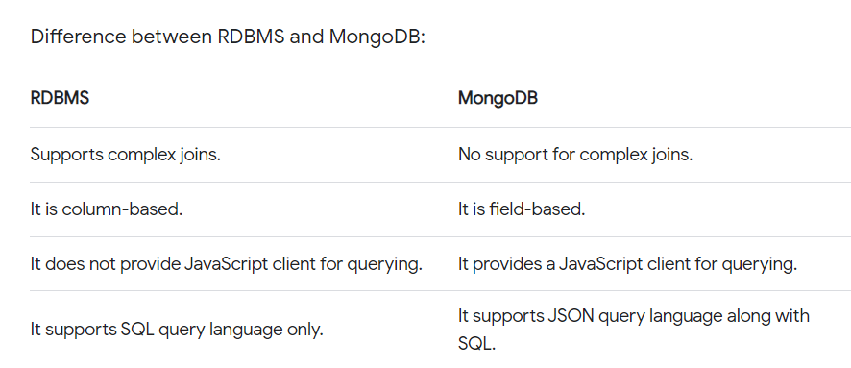

**Another Alternative is Casandra, it has its own drawbacks:**

[Cassandra](https://cassandra.apache.org/_/index.html) was initially started by Facebook. Cassandra's query language is called CQL.

* Cassandra does not support transactions. MongoDB supports fully ACID-compliant [transactions](https://docs.mongodb.com/manual/core/transactions/).

**Mongoose :**

1. **Used for Connection**
2. **Used for validation and schema definition:**

While we are saving we are validating whether our signup request is right or wrong if not as per the schema, we return an error.

**LOGIN AND SIGNUP :**